Unit 7: The UN matters
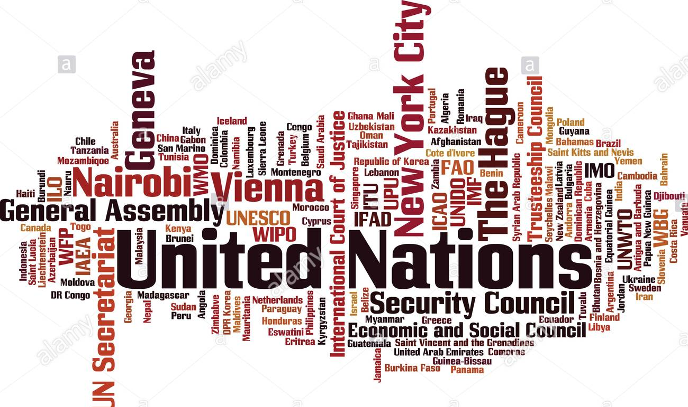

Name:
Number:
Class:

1 Intro
  - Activity
- Name one of the major problems facing the world today?

- Who or what organizations take care of these types of problems? Why? How?

- Complete the first two columns now with what you know about the UN and what you would like to know about the UN. Complete the last column during the last lesson.
What I know about the UN | What I would like to know about the UN | What I learned about the UN

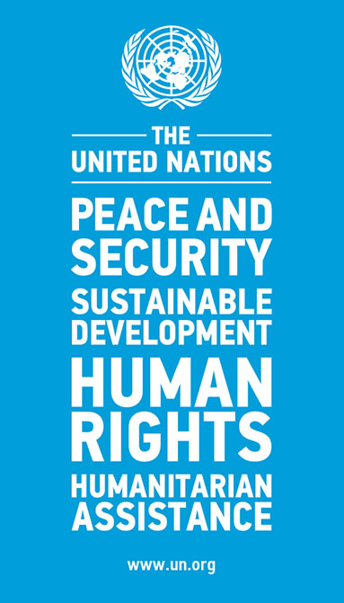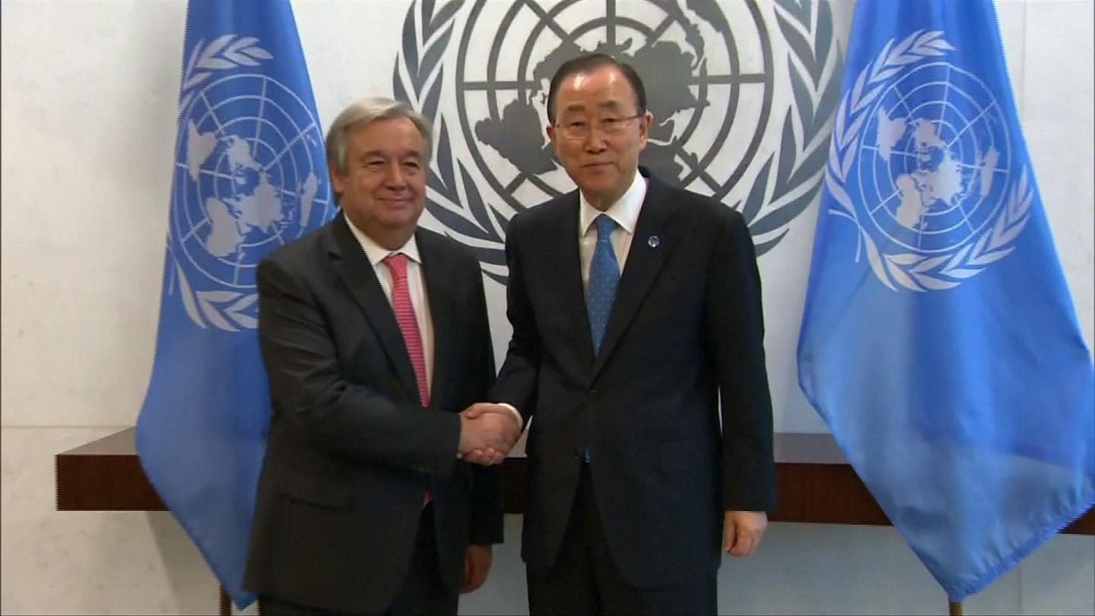
“UN peacekeeping is an investment in global peace, security and prosperity. The Blue Helmets are a concrete expression of the Charter’s determination to save succeeding generations from the scourge of war”.
António Guterres – Secretary-General, 6 April 2017

2 Context
The UN is an international organisation of sovereign states, containing nearly every country in the world. Only independent states may become members of the UN. It was created in the wake of World War II – in 1945, 51 states (including the UK) signed the UN Charter, and became the founding members of the UN. Because of the end of colonialism and the break-up of countries such as the USSR and Yugoslavia, the number of independent countries grew. Currently, the UN has 193 member states.
  - Activity

The United Nations is born
On October 24, 1945, the United Nations Charter, which was adopted and signed on June 26, 1945, is now effective and ready to be enforced.
The United Nations was born of perceived necessity, as a means of better arbitrating international conflict and negotiating peace than was provided for by the old League of Nations. The growing Second World War became the real impetus for the United States, Britain, and the Soviet Union to begin formulating the original U.N. Declaration, signed by 26 nations in January 1942, as a formal act of opposition to Germany, Italy, and Japan, the Axis Powers.
The principles of the U.N. Charter were first formulated at the San Francisco Conference, which convened on April 25, 1945. It was presided over by President Franklin Roosevelt, British Prime Minister Winston Churchill, and Soviet Premier Joseph Stalin, and attended by representatives of 50 nations, including 9 continental European states, 21 North, Central, and South American republics, 7 Middle Eastern states, 5 British Commonwealth nations, 2 Soviet republics (in addition to the USSR itself), 2 East Asian nations, and 3 African states. The conference laid out a structure for a new international organization that was to “save succeeding generations from the scourge of war,…to reaffirm faith in fundamental human rights,…to establish conditions under which justice and respect for the obligations arising from treaties and other sources of international law can be maintained, and to promote social progress and better standards of life in larger freedom.”
Two other important objectives described in the Charter were respecting the principles of equal rights and self-determination of all peoples (originally directed at smaller nations now vulnerable to being swallowed up by the Communist behemoths emerging from the war) and international cooperation in solving economic, social, cultural, and humanitarian problems around the world.
Now that the war was over, negotiating and maintaining the peace was the practical responsibility of the new U.N. Security Council, made up of the United States, Great Britain, France, the Soviet Union, and China. Each would have veto power over the other. Winston Churchill called for the United Nations to employ its charter in the service of creating a new, united Europe-united in its opposition to communist expansion-East and West. Given the composition of the Security Council, this would prove easier said than done.

History.com editors, published 16 November 2009, updated 21 October 2019. Read the source and

- Explain the origins of the U.N. and its aims of creating a world without conflict.

- What do you know about issues or current events that the UN has been involved in since its creation?

- Are you familiar with specific UN agencies, particularly as they relate to reaffirming fundamental human rights?

- Why do you think most of the world’s nations remain as members?

Challenge
- Do you know about any criticism the UN has faced over the years?

3 UN logo and flag
The logo and flag of the UN have become its symbols as it carries out its work on the world stage. They have the practical effect of identifying the United Nations in areas of trouble and conflict to any and all parties concerned. They are also aspirational symbols, for they speak to the hopes and dreams of people the world over, for peace and unity.
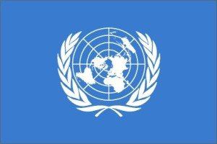
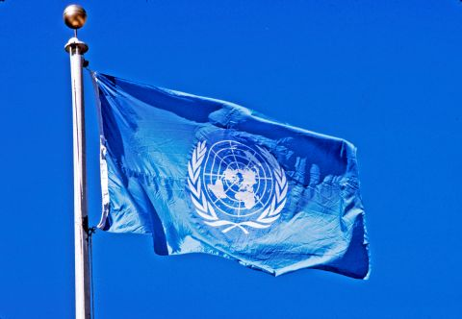
UN Photo/John Isaac
The flag of the United Nations, with its white emblem on a light blue field, flies from a pole in front of UN Headquarters in New York.

The United Nations Emblem
Oliver Lincoln Lundquist, a talented architect and industrial designer, worked for the Office of Strategic Services (OSS), CIA’s predecessor, during World War II and led the team that designed the official United Nations emblem.
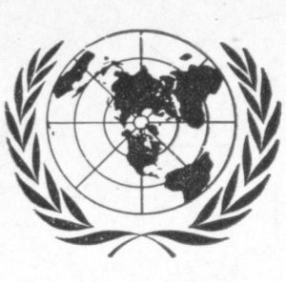
In 1945, the US State Department asked the OSS to help create graphics for the UN Conference on International Organization in San Francisco, where the UN Charter was drafted. Lundquist’s team set out to create a lapel pin for the delegates that could serve as their official form of identification. This became the prototype for the UN logo you see today.
Prototype

The design consisted of a top-down view of the globe, centered on North America and showing all of the continents except Antarctica, with two olive branches on either side to symbolize peace. The design was in shades of blue, a purposeful choice to contract with red, a color traditionally associated with war.

4 What do they do?
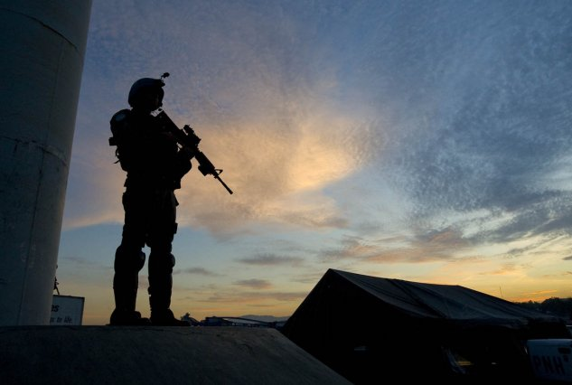
  - Maintain International Peace and Security
The United Nations came into being in 1945, following the devastation of the Second World War, with one central mission: the maintenance of international peace and security. The UN does this by working to prevent conflict; helping parties in conflict make peace; peacekeeping; and creating the conditions to allow peace to hold and flourish. These activities often overlap and should reinforce one another, to be effective. The UN Security Council has the primary responsibility for international peace and security. The General Assembly and the Secretary-General play major, important, and complementary roles, along with other UN offices and bodies.
  - Protect human rights
The term “human rights” was mentioned seven times in the UN's founding Charter, making the promotion and protection of human rights a key purpose and guiding principle of the Organization. In 1948, the Universal Declaration of Human Rights brought human rights into the realm of international law. Since then, the Organization has diligently protected human rights through legal instruments and on-the-ground activities.

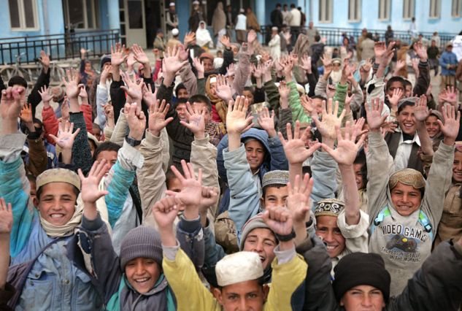
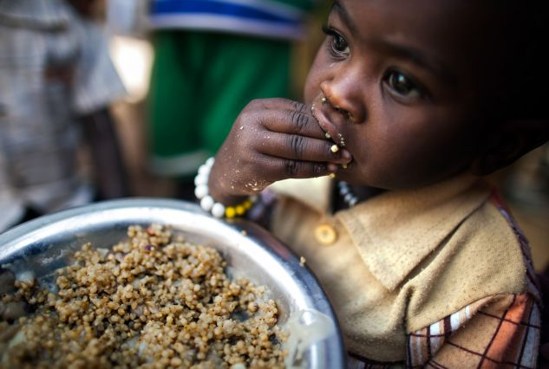
  - Deliver humanitarian aid
One of the purposes of the United Nations, as stated in its Charter, is "to achieve international co-operation in solving international problems of an economic, social, cultural, or humanitarian character." The UN first did this in the aftermath of the Second World War on the devastated continent of Europe, which it helped to rebuild. The Organization is now relied upon by the international community to coordinate humanitarian relief operations due to natural and man-made disasters in areas beyond the relief capacity of national authorities alone.

UN Photo/Fardin Waezi- Students at Butkhak High School in Kabul, Afghanistan, cheer in unison on the last day of Global Action Week, an international campaign advocating free, quality education for all.

UN Photo/Albert González Farran
A child has a meal at a food distribution centre in the Rwanda camp for internally displaced persons (IDPs), near Tawila, North Darfur. More than 8,000 women and children living in the camp benefit from nutrition programmes run by the World Food Programme (WFP).

UN Photo/Riccardo Gangale
Grace, a farmer from Kipilat village, and a leading member of the forest community in Ainabkoi, Kenya, planting a tree in 2012.

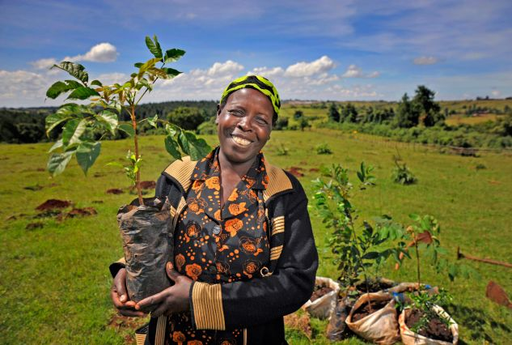

  - Promote sustainable development
From the start in 1945, one of the main priorities of the United Nations was to “achieve international co-operation in solving international problems of an economic, social, cultural, or humanitarian character and in promoting and encouraging respect for human rights and for fundamental freedoms for all without distinction as to race, sex, language, or religion.” Improving people’s well-being continues to be one of the main focuses of the UN. The global understanding of development has changed over the years, and countries now have agreed that sustainable development – development that promotes prosperity and economic opportunity, greater social well-being, and protection of the environment – offers the best path forward for improving the lives of people everywhere.

The UN Charter, in its Preamble, set an objective: "to establish conditions under which justice and respect for the obligations arising from treaties and other sources of international law can be maintained". Ever since, the development of, and respect for international law has been a key part of the work of the Organization. This work is carried out in many ways - by courts, tribunals, multilateral treaties - and by the Security Council, which can approve peacekeeping missions, impose sanctions, or authorize the use of force when there is a threat to international peace and security, if it deems this necessary. These powers are given to it by the UN Charter, which is considered an international treaty. As such, it is an instrument of international law, and UN Member States are bound by it. The UN Charter codifies the major principles of international relations, from sovereign equality of States to the prohibition of the use of force in international relations.
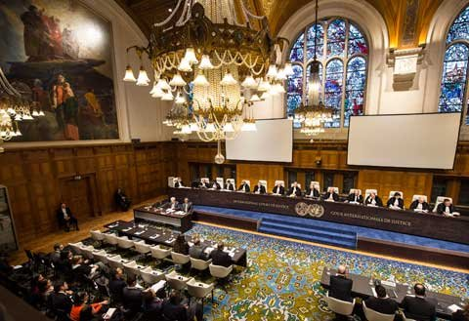

UN Photo/ICJ-CIJ
The International Court of Justice (ICJ) delivers its order on the request for the indication of provisional measures filed by Nicaragua on 11 October 2013 in the case concerning Construction of a Road in Costa Rica along the San Juan River (Nicaragua v. Costa Rica).

  - Uphold International Law

Activity
What does the UN want to achieve?

What is according to you, the biggest challenge for the UN today? Support your opinion with a current affairs item. (PEE: point – evidence from article – explain)

4 How does it work?
  - Activity
Watch the clips https://www.youtube.com/watch?v=QoIafzc0k74 / https://www.youtube.com/watch?v=tlmYtJiUK00
The aims are: you are able to describe the general structure of the UN (hard) – you are able to explain the power of the central bodies of the UN (harder) – you are able to evaluate the relative power of the central bodies (challenge).

- Explain the general structure of the UN. Use the key words in your text. Write on a separate sheet.
Security council – 5 permanent members – France – Britain – China – The United States – Russia – all winning powers of World War II – veto power – 10 members on a rolling bases every 2 years – world regions to have representation -
General Assembly – where all the members meet in September – single vote for each country – Vatican – Palestine – no
Social and economic council – improve standards of living – human rights –
International court of justice – the Hague – international law violations –
Secretariat – internal administrative working – compile reports – communicate between the different councils – headed by the UN secretary general -
Make resolutions – to make policy for the world
Responsible for eradicating polio – dealing of problems with debt – problems of other diseases spreading member observer states
Declaration of human rights
Primary purpose –helping developing countries – Word Health Organisation – peace
- Explain the power of the central bodies.

Challenge
- Evaluate the relative power of the UN bodies.

5 The 17 Goals
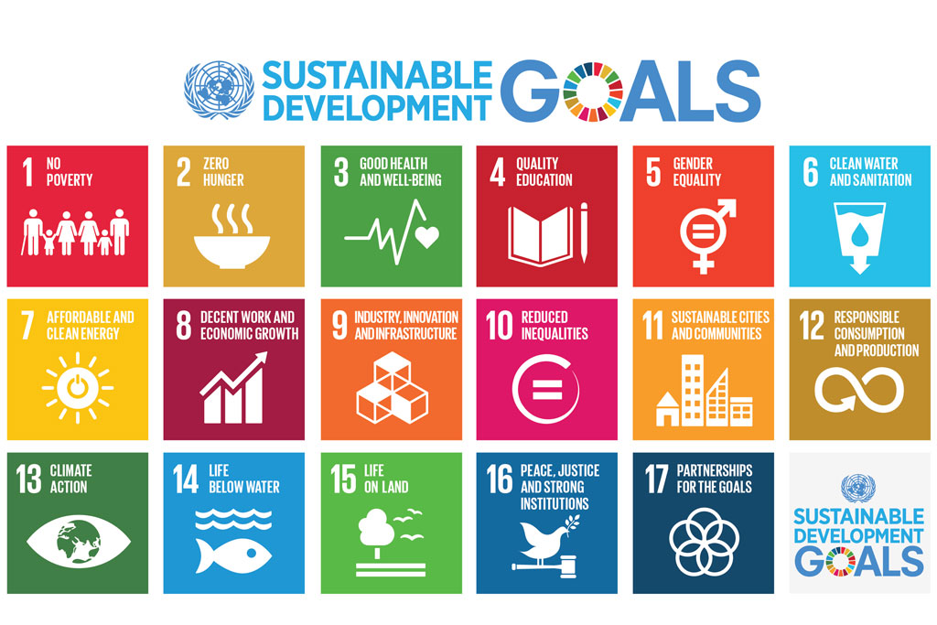In 2015, world leaders agreed to 17 goals for a better world by 2030. These goals have the power to end poverty, fight inequality and address the urgency of climate change. Guided by the goals, it is now up to all of us, governments, businesses, civil society and the general public to work together to build a better future for everyone.

7 Funds, Programmes, Specialized Agencies and Others
The UN system, also known unofficially as the 'UN family', is made up of the UN itself and many programmes, funds, and specialized agencies, all with their own leadership and budget. The programmes and funds are financed through voluntary rather than assessed contributions. The Specialized Agencies are independent international organizations funded by both voluntary and assessed contributions.
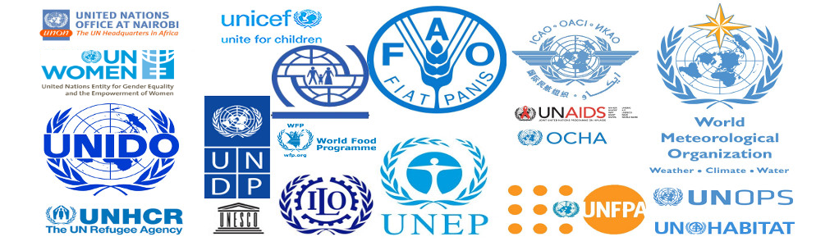

  - Activity
Go to the following link and read through the list. Select one of the fund or programmes you’re interested in (https://www.un.org/en/sections/about-un/funds-programmes-specialized-agencies-and-others ) and
- Identify the agency (topical questions) ( /2)
- Research one article from a reliable source that was published on this agency no later than August 2019 ( /2)
- Summarize the content of the article ( /3)
- How would you tackle this issue? Use your knowledge from this unit. ( /3)

7. Why is the UN criticized?
Over the years, the role of the U.N. has expanded from an organization that focused on peace and security to one that includes a wide range of global concerns. Today, the U.N. provides solutions for problems related to healthcare, the environment, criminal justice, refugee dilemmas and more.
Though many support including these extended responsibilities, others believe the organization may be overstepping its boundaries.
The U.N. has also faced criticism for promoting globalization, not being effective enough, backing provocative policies, providing controversial health options, being too bureaucratic, giving certain countries more power than others and spending too much money.
  - Activity
Which aspects are you critical of? Name and explain 2. Use your knowledge from this unit, as your knowledge of current affairs.

Sources
https://www.un.org/en/
https://www.una.org.uk/get-involved/learn-and-teach/overview-united-nations
https://www.pbs.org/newshour/extra/lessons-plans/students-examine-u-n-s-goals-on-70th-anniversary-lesson-plan/
https://www.una.org.uk/sites/default/files/Glossary.pdf
https://www.history.com/this-day-in-history/the-united-nations-is-born
https://www.un.org/en/sections/about-un/un-logo-and-flag/index.html
https://watch.globalgoals.org/
https://www.theguardian.com/world/2015/sep/07/what-has-the-un-achieved-united-nations
https://www.history.com/topics/world-war-ii/united-nations
http://www.educatingexcellence.com/uploads/1/2/3/2/12327484/lesson_1-introduction_to_the_un_middle_school.pdf (activity)
https://worldslargestlesson.globalgoals.org/

